11/21/2024
Sumama Rahim;sumama.rahim@yandex.com
F24BSCS-039
Lab Mid
Word Processing Preparation

MS Word
Lorem ipsum dolor sit amet, consectetuer adipiscing elit. Maecenas porttitor congue massa. Fusce posuere, magna sed pulvinar ultricies, purus lectus malesuada libero, sit amet commodo magna eros quis urna.
Nunc viverra imperdiet enim. Fusce est. Vivamus a tellus.
Pellentesque habitant morbi tristique senectus et netus et malesuada fames ac turpis egestas. Proin pharetra nonummy pede. Mauris et orci.
Aenean nec lorem. In porttitor. Donec laoreet nonummy augue.
Suspendisse dui purus, scelerisque at, vulputate vitae, pretium mattis, nunc. Mauris eget neque at sem venenatis eleifend. Ut nonummy.
Practical 1
- Type a paragraph in Calibri Font
- Font size will be 12
- Change style to Calligraphy style font
- Alignment of the paragraph
- Close the file
Practical 2
- Use multi tools
- Type a paragraph in other font style
- Do whatever
- Draw line
Practical 3
Use tables
Name | Registration# | Course | CH
Ali | F24BSCS-023 | CS101 | 3+2
Ahmad | F24BSCS-019 | CS110 | 3+2
Mustafa | F24BSCS-071 | MT101 | 3
Salim | F24BSCS-055 | MG202 | 3

Now I am using a picture
Mapping of Lab CLO’s to PLO’s
 | Engineering Knowledge | Problem Analysis | Design/Development of Solution | Investigation | Modern Tool Usage | Engineer and Society | Environment and Sustainability | Ethics | Individual and Teamwork | Communication Skills | Project Management | Lifelong Learning
 | PLO1 | PLO2 | PLO3 | PLO4 | PLO5 | PLO6 | PLO7 | PLO8 | PLO9 | PLO1 | PLO1 | PLO1
CLO5
CLO6

Tentative Schedule
Week | Topics/In-Class Activities | Assessments | Suggested Readings | CLO
Week 1 | - Introduction and Importance of ICT, uses of ICT in education,  - Introduction to computer, classification of computers,  - Components of computer, some basic definitions.  LAB: MS OFFICE INSTALLATION | Quiz, Mid Term and Assessments | Chapter 1  Misty E. Vermaat et al.
Week 2 | Types of Computers  - Super, Mainframe, Mini and Micro Computer,  - Analog, Digital & Hybrid Computers,  - (Single-user Computer, Multi-user Computer)  - General & Special Purpose Computer  - Generation of Computers. |  | Chapter 1  Misty E. Vermaat et al. | CLO 1
Week 3
Week 4
Week 5
Week 6
Week 7
Week 8
Week 9 |  | Mid
Week 10
Week 11
Week 12
Week 13
Week 14
Week 15
Week 16
Week 17
Week 18

Page Formatting
Lorem ipsum dolor sit amet, consectetuer adipiscing elit. Maecenas porttitor congue massa. Fusce posuere, magna sed pulvinar ultricies, purus lectus malesuada libero, sit amet commodo magna eros quis urna.
Nunc viverra imperdiet enim. Fusce est. Vivamus a tellus.
Pellentesque habitant morbi tristique senectus et netus et malesuada fames ac turpis egestas. Proin pharetra nonummy pede. Mauris et orci.
Aenean nec lorem. In porttitor. Donec laoreet nonummy augue.
Suspendisse dui purus, scelerisque at, vulputate vitae, pretium mattis, nunc. Mauris eget neque at sem venenatis eleifend. Ut nonummy.
Fusce aliquet pede non pede. Suspendisse dapibus lorem pellentesque magna. Integer nulla.
Donec blandit feugiat ligula. Donec hendrerit, felis et imperdiet euismod, purus ipsum pretium metus, in lacinia nulla nisl eget sapien. Donec ut est in lectus consequat consequat.
Etiam eget dui. Aliquam erat volutpat. Sed at lorem in nunc porta tristique.
Proin nec augue. Quisque aliquam tempor magna. Pellentesque habitant morbi tristique senectus et netus et malesuada fames ac turpis egestas.
Nunc ac magna. Maecenas odio dolor, vulputate vel, auctor ac, accumsan id, felis. Pellentesque cursus sagittis felis.
Lorem ipsum dolor sit amet, consectetuer adipiscing elit. Maecenas porttitor congue massa. Fusce posuere, magna sed pulvinar ultricies, purus lectus malesuada libero, sit amet commodo magna eros quis urna. Nunc viverra imperdiet enim. Fusce est. Vivamus a tellus. Pellentesque habitant morbi tristique senectus et netus et malesuada fames ac turpis egestas. Proin pharetra nonummy pede. Mauris et orci. Aenean nec lorem. In porttitor. Donec laoreet nonummy augue. Suspendisse dui purus, scelerisque at, vulputate vitae, pretium mattis, nunc. Mauris eget neque at sem venenatis eleifend. Ut nonummy.

Flowchart
START
END

FALSE
TRUE

SIMPLE CYCLE of a process

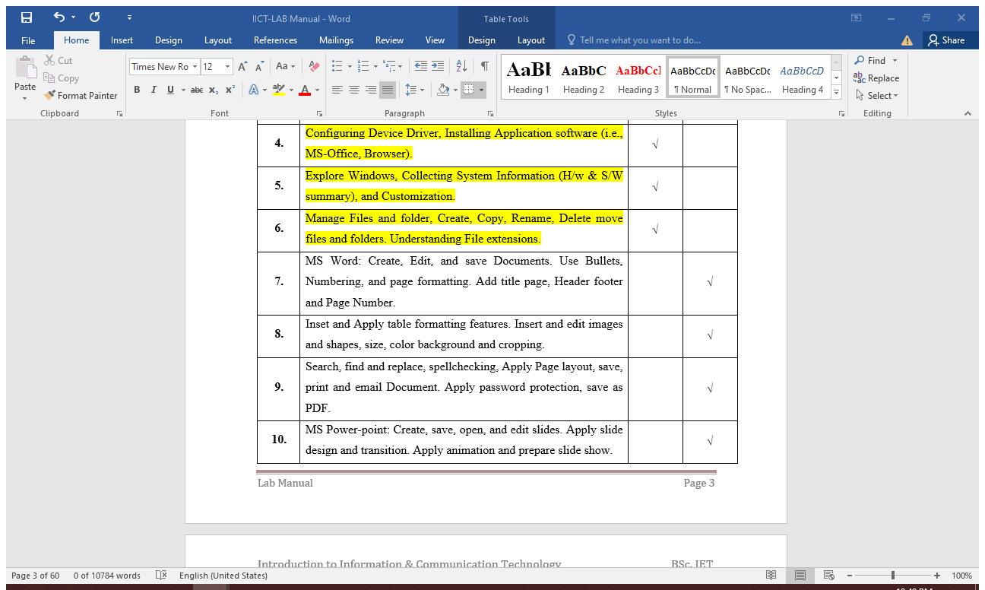
CONTACT AND PERSONAL INFO

EXPERIENCE:
Microsoft
- DevOps – 6 Years
- Cyber Security Analyst – 10 Years
- Cyber Security Engineer – 10 Years
Google
- Cryptography Engineer – 10 Years
- Encryption and Decryption Engineer - 15 Years
Name: ABC
DOB: 2000

EDUCATION

MS Computer Science
- Major in Cyber Security – Networking
- FYP Google Security Project
- FYP Microsoft Cloud Security
BS Computer Science
- Major in Cyber Security
- FYP Self Driving Car Security
- FYP Self Driving Space Shuttle and Vehicles
Certification Name | Certified by | Reg# | Status
CEH | IBM | LH9273A | Valid
CSSP | Microsoft | FD2793S | Valid
CCSE | Google | CS9816A | Valid
International Certifications
Table of Contents
Type chapter title (level 1) 1
Type chapter title (level 2) 2
Type chapter title (level 3) 3
Type chapter title (level 1) 4
Type chapter title (level 2) 5
Type chapter title (level 3) 6

Good day footnote

Oh it is awesome

End note which is in last of all pages
This is citation to the reference of book (Sumama, 2020) ,

Bibliography
Sumama. (2020). Author of the book. Islamabad: Sumahim Press.

Figure 1: caption 1

Sumama Rahim;sumama.rahim@yandex.com

[Company E-mail]

Lab Mid
[Company E-mail]

11/21/2024
[Company Phone]
Sumama Rahim;sumama.rahim@yandex.com

$y_{-}^{T⋅f^{-}}=9$

Table Formatting
Name | Reg# | Calculus | ICT | PF | Discrete | English | CGPA | Total Marks
Ali | F24BSCS011 | 77 | 78 | 63 | 83 | 71 | 3.1 | 385
Ahmad | F24BSCS091 | 71 | 76 | 81 | 61 | 89 | 3.2 | 393
Usama | F24BSCS097 | 89 | 79 | 91 | 84 | 76 | 3.7 | 377
Usman | F24BSCS075 | 93 | 83 | 79 | 63 | 69 | 3.4 | 431
Nadeem | F24BSCS017 | 67 | 88 | 77 | 73 | 81 | 3.1 | 401
Saad | F24BSCS193 | 93 | 66 | 89 | 82 | 83 | 3.3 | 443
Hamza | F24BSCS071 | 93 | 97 | 85 | 71 | 79 | 3.4 | 439

Mailing
{sumama.rahim@yandex.com}
«AddressBlock»
«GreetingLine»

Lorem ipsum dolor sit amet, consectetuer adipiscing elit. Maecenas porttitor congue massa. Fusce posuere, magna sed pulvinar ultricies, purus lectus malesuada libero, sit amet commodo magna eros quis urna.
Nunc viverra imperdiet enim. Fusce est. Vivamus a tellus.
Pellentesque habitant morbi tristique senectus et netus et malesuada fames ac turpis egestas. Proin pharetra nonummy pede. Mauris et orci.
Aenean nec lorem. In porttitor. Donec laoreet nonummy augue.
Suspendisse dui purus, scelerisque at, vulputate vitae, pretium mattis, nunc. Mauris eget neque at sem venenatis eleifend. Ut nonummy.

Lorem ipsum dolor sit amet, consectetuer adipiscing elit. Maecenas porttitor congue massa. Fusce posuere, magna sed pulvinar ultricies, purus lectus malesuada libero, sit amet commodo magna eros quis urna.
Nunc viverra imperdiet enim. Fusce est. Vivamus a tellus.
Pellentesque habitant morbi tristique senectus et netus et malesuada fames ac turpis egestas. Proin pharetra nonummy pede. Mauris et orci.
Aenean nec lorem. In porttitor. Donec laoreet nonummy augue.
Suspendisse dui purus, scelerisque at, vulputate vitae, pretium mattis, nunc. Mauris eget neque at sem venenatis eleifend. Ut nonummy.

Lorem ipsum dolor sit amet, consectetuer adipiscing elit. Maecenas porttitor congue massa. Fusce posuere, magna sed pulvinar ultricies, purus lectus malesuada libero, sit amet commodo magna eros quis urna.
Lorem ipsum dolor sit amet, consectetuer adipiscing elit. Maecenas porttitor congue massa. Fusce posuere, magna sed pulvinar ultricies, purus lectus malesuada libero, sit amet commodo magna eros quis urna.
Aenean nec lorem. In porttitor. Donec laoreet nonummy augue.
Suspendisse dui purus, scelerisque at, vulputate vitae, pretium mattis, nunc. Mauris eget neque at sem venenatis eleifend. Ut nonummy.

Fig. 3.2: Sun Shining etc
Lorem ipsum dolor sit amet, consectetuer adipiscing elit. Maecenas porttitor congue massa. Fusce posuere, magna sed pulvinar ultricies, purus lectus malesuada libero, sit amet commodo magna eros quis urna.
Pellentesque habitant morbi tristique senectus et netus et malesuada fames ac turpis egestas. Proin pharetra nonummy pede. Mauris et orci.
.
Fig. 3.3: How a leaf is this etc
Suspendisse dui purus, scelerisque at, vulputate vitae, pretium mattis, nunc. Mauris eget neque at sem venenatis eleifend. Ut nonummy

Footnote
It is footnote 2
These are endnote

